**Monetary Model**

After exploring the data now you are required to implement a Monetary model for customers behavior for product purchasing and segment each customer based on the below groups

***Champions - Loyal Customers - Potential Loyalists – Recent Customers – Promising - Customers Needing Attention - At Risk - Cant Lose Them – Hibernating – Lost***

The customers will be grouped based on 3 main values

* • **Recency** => how recent the last transaction is (**Hint**: choose a reference date, which is the most recent purchase in the dataset )
* • **Frequency** => how many times the customer has bought from our store
* • **Monetary** => how much each customer has paid for our products

As there are many groups for each of the R, F, and M features, there are also many potential permutations, this number is too much to manage in terms of marketing strategies.

For this, we would decrease the permutations **by getting the average scores of the frequency and monetary** (as both of them are indicative to purchase volume anyway)

-----------------------------------------------------------------------------------------------------

to get the reference date, which is the most recent purchase in the dataset

select date(InvoiceDate) from tableretail

order by InvoiceDate desc

limit 1;

reference date ='2011-12-09'

--------------------------------------------------------

The recency score is assigned based on the following criteria:

Customers who made a purchase in the last 60 days are assigned a score of 5.

Customers who made a purchase between 61 and 90 days ago are assigned a score of 4.

Customers who made a purchase between 91 and 130 days ago are assigned a score of 3.

Customers who made a purchase between 131 and 180 days ago are assigned a score of 2.

Customers who made a purchase more than 180 days ago are assigned a score of 1.

This criteria assigns higher recency scores to customers who made a purchase more recently, and lower scores to customers who made a purchase a long time ago.

--------------------------------------------------------------------------------------------

Frequency Monetary (FM) score is a method used in customer segmentation to identify and group customers based on their purchasing behavior. It takes into account the frequency and monetary value of a customer's purchases.

To calculate FM score for a customer, you need to follow these steps:

Determine the number of times the customer has made a purchase (frequency).

Calculate the total amount of money the customer has spent on purchases (monetary value).

Assign a score to the customer based on their frequency and monetary value, using a formula or table specific to your business.

One common approach is to use a scoring system based on quartiles. For example, you could assign a score of 1 to customers in the bottom 20% of both frequency and monetary value, a score of 2 to customers in the second quartile and so on up to a score of 5 for customers in the top 20% of both frequency and monetary value.

--------------------------------------------------------------------------------------------

Customer segmentation Criteria

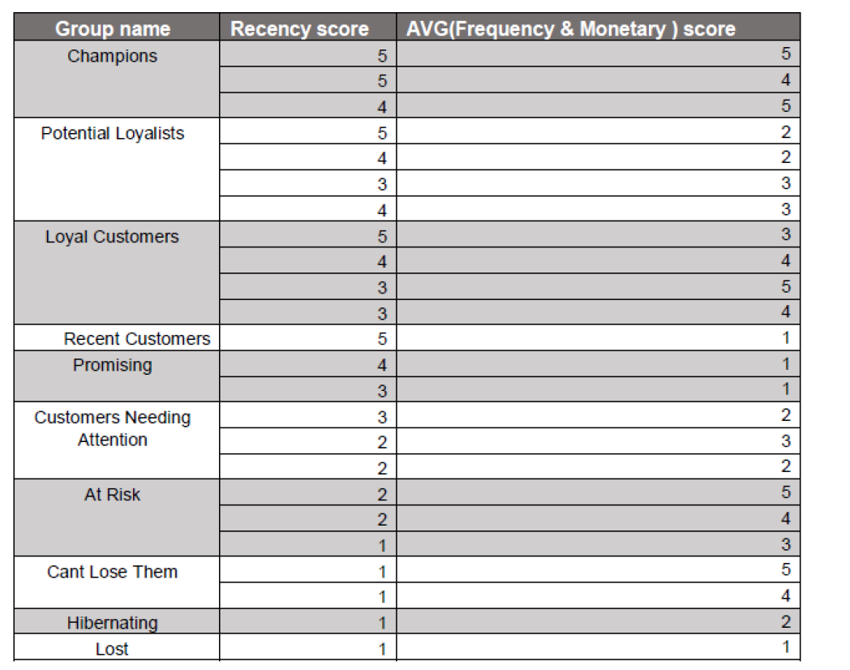

The query Output:

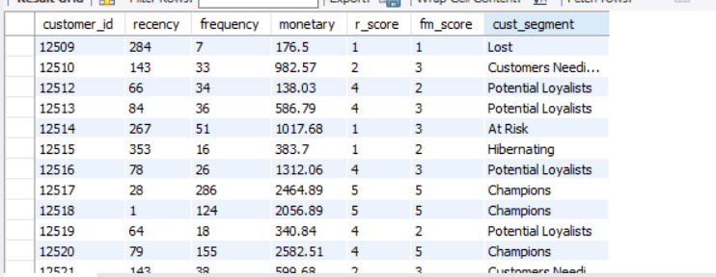

The way I calculated fm_score is taking the average of f_score & m_score:

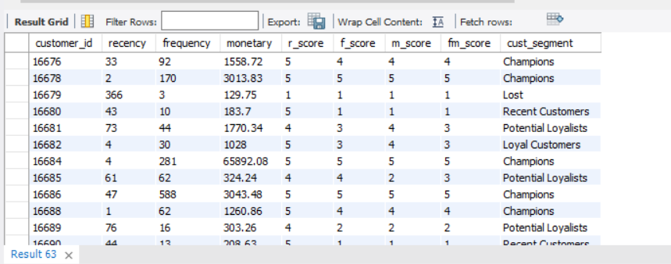

Each of f_score & m_score are divided into 5 quartiles based on the range of values of frequency & monetary columns.

the number of times the customer has made a purchase (frequency column).

total amount of money the customer has spent on purchases (monetary column).